Question 01 (15 mints) (10 marks)

Below are the estimation forms from a Wideband Delphi estimation meeting. There are 5 tasks (A-E) and 3 members (M1, M2, M3). The numbers in the tables indicate days (note: not delta) that a member thinks will take to complete a task.

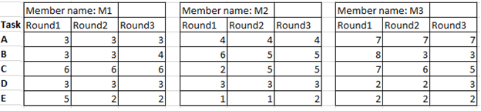

Given this data, do the following:

1. Show how the meeting progressed by drawing the result graph.

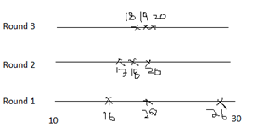

1. Demonstrate how the summarized result of estimation form mentioning the best, worst and average cases can be created using the given data.

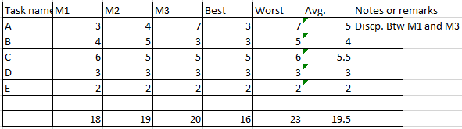

Question 02 ( 25 mints) (10 marks)

Basis path testing, a structured testing or white box testing technique used for designing test cases intended to examine all possible paths of execution at least once. Creating and executing tests for all possible paths results in 100% statement coverage and 100% branch coverage.they derives the number of ‘test cases’ that can be designed to exercise each & every statement in the program at the minimum once while testing is conducted to uncover all the possible errors of the program. Basis path testing is a method of testing the control structure of conventional software.Calculate the independent paths of the given program and create a Binary flow Graph.

* + public static int main(String[] args) {
    - // TODO Auto-generated method stub
    - int num = 0, done = 10;
    - int line1 = 1;
    - int line2 = 2;
    - int nline = 5;
    - while(done == 10 ) {
      * System.out.println("welcome to Software Engineering");
      * line1 = line2;
      * line2 = num;
      * line1 -=2;
      * num++;
      * nline++;
      * if(line1== line2)
        + System.out.println("true");
      * if(num == nline) {
        + System.out.println("true");
      * }
      * else {
        + System.out.println("false");
        + done--; }
    - }
    - if(line1 == 0)
      * System.out.println("true");
    - if(line2 == 0)
      * System.out.println("False");
    - if(nline == 0)
      * System.out.println("true");
      * Return 0;
  + }
* }

Solution of binary flow graph

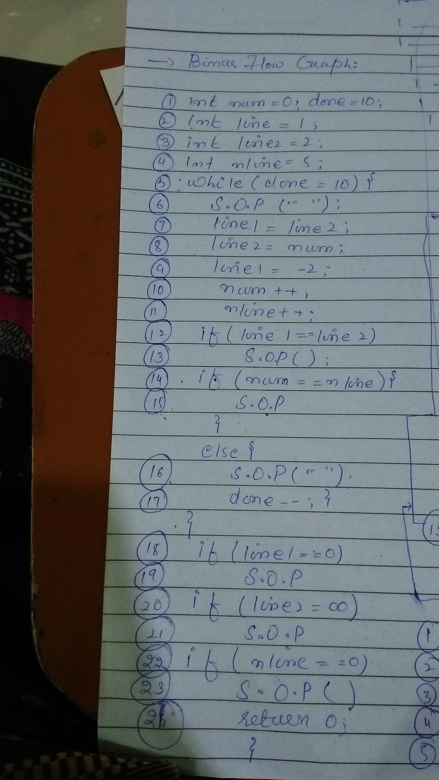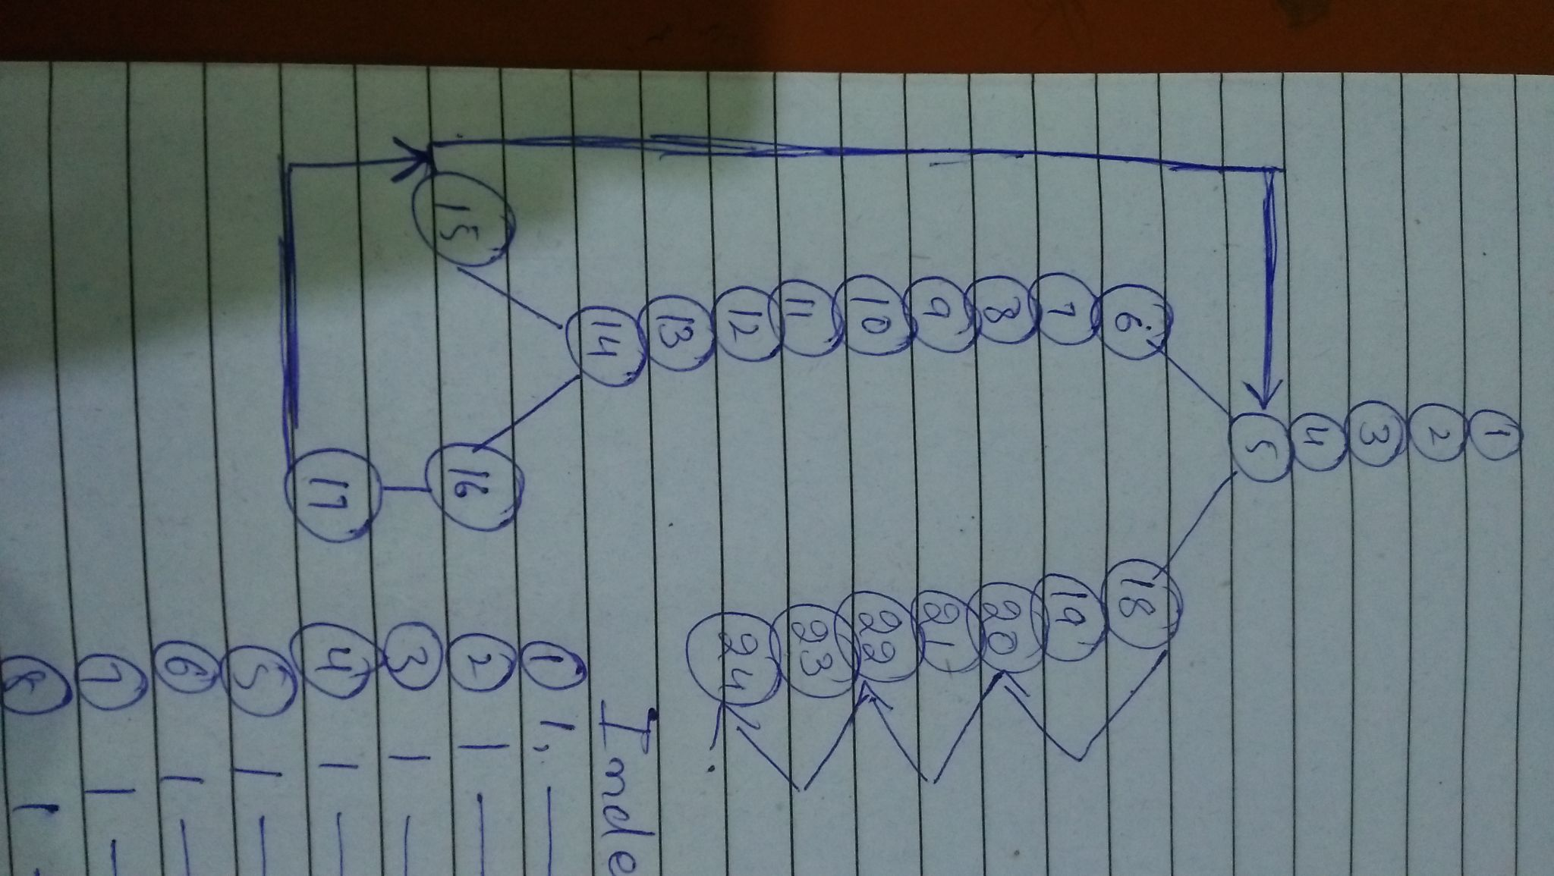

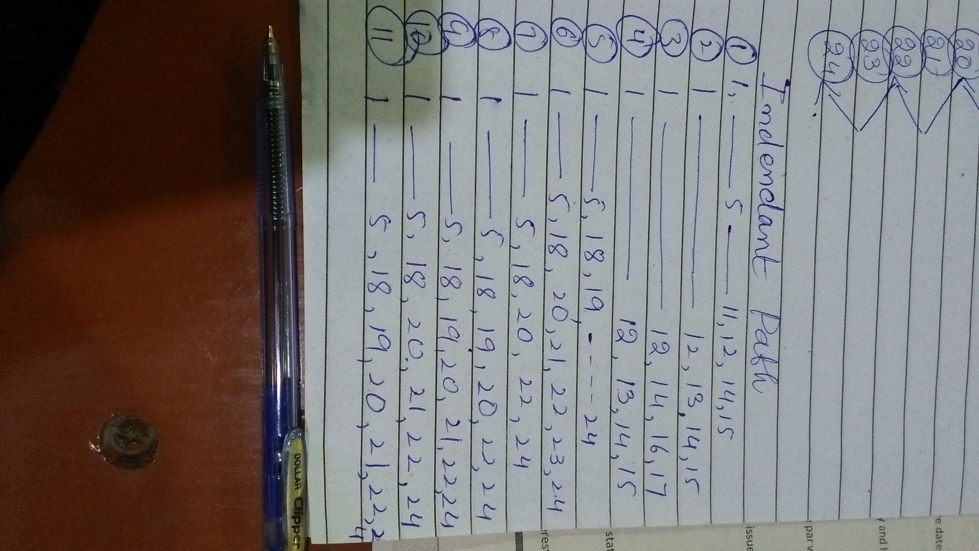

Question 03 (10 mints)

The concept of charity is all about helping the needy people with the contribution of multiple NGOs. There is an organization that wants to convert charity concepts into digital form. The project is a charity website that aims at bringing together the donors and the recipients of charity on a single platform digitally. The objective is to make giving those in need as common and easy as possible. Apart from donating to various NGOs the online site also supports giving donations to needy who are not part of NGOs. This creates awareness and support for street beggars, old people, and all the underprivileged people who are otherwise neglected. This is made possible through the website as it provides a single platform that allows individuals to create separate profiles as representatives of such unnoticed underprivileged people and upload statuses that donors can reach. Charity can be given in the form of cash, food, and books by means of either self-delivering or getting materialistic things picked up from location. Donor and recipient history is maintained, where all the charity actions and transactions are saved for the account holders to view. The vision is to minimize poverty and hence reduce crime rate as much as possible in Pakistan. It assures complete privacy of each account registered and since recipients are fully verified, the software also minimizes deception and fraud.

The services that is provided by this Charity Website are followings

· Home

· Registration

· Login

· Donation

· Post

· View Donation

· View Profile

These services are verified by system logical process., system authority must be responsible to interact with data repositories. All the required data is maintained in individual components. Likewise Separate repository for following services

· Login

· Post

· Donation

· No of NGOs

**Identify the number of layers and their components and create a complete architecture diagram with all required components that are mentioned in requirements.**

**Solution:** 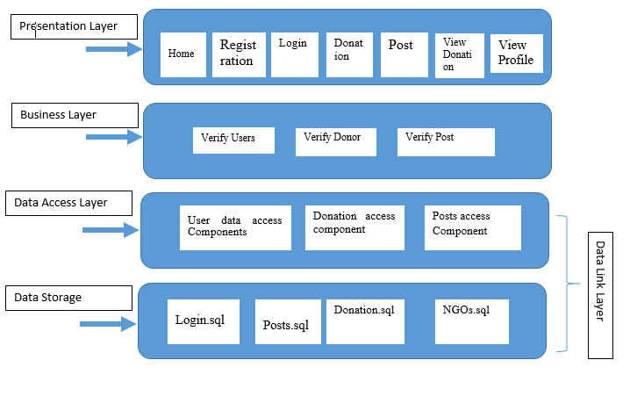

Question 04 (25 mints) 5 marks each question

Short question/ answers.

1. What is the difference between Validation and verification, justify with real world examples.

Sol: Verification: Building the product right

Validation: Building the right product

Any examples

1. Differentiate how load testing is differ from stress testing. Discuss one real world scenario where each would be useful.

Sol: Load testing is performed to find out the upper limit of the system or application. Stress testing is performed to find the behavior of the system under pressure.

1. (Imagine that a government wants a software program that helps to keep track of the utilization of the country’s vast mineral resources. A software company was tasked with the development of a prototype. The government found the prototype impressive, and asked it be extended to be the actual system that would be used. Discuss at least 3 cons of taking this approach.)

Sol: This is evolutionary prototype as govt. Is asking s.w house to extend the prototype to actual system. (Cons of evolutionary prototype as answer)

1. Unit testing should be performed using automated testing whenever it is possible. There are three components of the automated testing. Specify those three components with an example.

Sol: A setup part, where you initialize the system with the test case, namely the inputs and expected outputs.

A call part, where you call the object or method to be tested.

An assertion part where you compare the result of the call with the expected result. If the assertion evaluates to true, the test has been successful; if false, then it has failed.

1. Compare and contrast acceptance testing and release testing. Why is it important to carry out acceptance and release testing even if exhaustive development tasking has been done?

Sol: Release: Performed by team other than dev team. Mainly blackbox and validation.

Acceptance testing: Performed by users.

1. Based on your knowledge of FAST Karachi campus, which level of process maturity model would FAST Karachi campus currently occupy? Justify your answer by giving examples of how FAST matches the requirements set out for that maturity level. Please note, your answer should be based on facts and not your personal opinions.

Sol: Could be defined or Managed depending on justification. Defined because processes are in place at organizational level. Managed because QEC activities take place and measurements are done.

1. Define what ethnographic studies are. Give two disadvantages of ethnographic studies in understanding software requirements.

Sol: Go to users’ environment and observe them at work.

Cons: Does not help in innovation

Narrow view.

1. What are the entities Product Owner and Scrum master in Agile. What is the difference between Product Owner and Product Manager and Scrum master and Product Manager?

PO is a member of the Agile Team responsible for defining Stories and prioritizing the Team Backlog to streamline the scrum process

PM is essentially the same. The main difference is PM is concerned with more higher level things. (Note: If someone writes that there is no PM in agile or scrum, it is also OK)

A Scrum Master works in smaller scrum teams. They are responsible for the performance of their small scrum team. Makes sure scrum practices are followed. Streamlines communication between team. Ideally should not have stake in the project

Question 05 (15 mints)

Consider a data flow diagram for the ATM machine, where a user interacts with the machine in order to check balance or withdraw amount. User gives some inputs and gets the outputs. ATM machine has subsystems like Cash dispenser to get the amount from the machine. The data flow diagram is evaluated to determine a set of key information domain measures required for computation of the function point metric. Determine the domain measurements from the following data flow diagram and calculate the functional points for the system, when complexity adjustment factors are essential and weighting factor complex. Refer to the table given below.

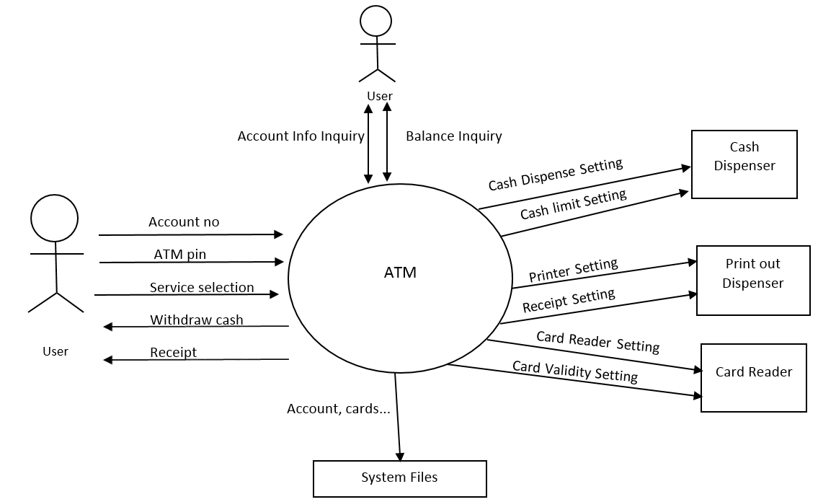

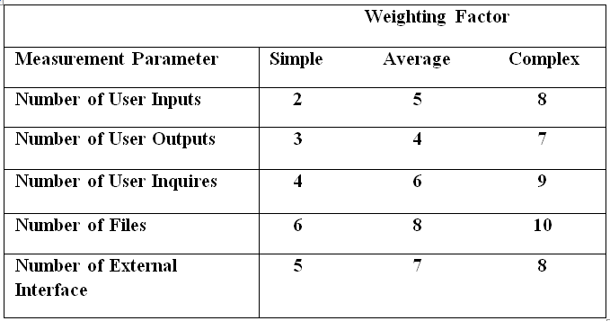

Answer: Fi= 14x 5= 70 //In question all Value adjustment factors are essential so 5

No. of user inputs= 3

No. of user outputs= 2

No. of inquires = 2

No. of files= 1

No. of external interface= 6

Weighting factor is complex so

3x8= 24

2x7= 14

2x9 = 18

1x10 = 10

6x8= 48

Total count= 114

FP=Total count x[0.65 +(0.01 x Fi)]

FP = 114 x [0.65+ (0.01x 70)]

FP= 114x [0.65+0.7 ]

FP= 114 x 1.35

**FP= 153.9**

Question 06 (10 mints)

The sequence diagram helps you design the specific test cases that you need, as it shows what inputs are required and what outputs are created. The following diagram shows the inputs and outputs for the online purchase. Drive at least 5 Test cases from the following sequence diagram required to perform proper testing.

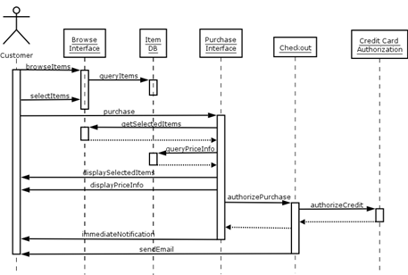

Question 7: (10 mints)

Refactor the following code. Apply at least two changes that are considered part of refactoring. (Note: Clearly identify the changes that you have made.)

public class MyClass {

public static void MyClassFunction(String MovieName, int charges){

public int CDs = 50;

public int StreamAccess = 1000;

public int BluRay = 100;

public int a;

public return charges;

public int charges;

int a=charges;

if(a=="CD")

charges=CDs*days;

else if(a=="StreamAcess")

charges=StreamAccess*days;

else if(a=="BluRay")

charges=BluRay*days;

returncharges=charges;

return returncharges;

}

}

Sol: Variable names should be appropriate, Extra lines/ variables should be removed, code should be commented

Question 08: ( 5 mints)

~~Reuse-based software engineering is a software engineering strategy where the development process is geared to reusing existing software. The move to reuse-based development has been in response to demands for lower software production and maintenance costs, faster delivery of systems, and increased software quality.~~

How does COTS -Commercial-off-the-shelf system affect the concept reusability of software engineering? If any organization adopts off the shell component, then what kind of steps they need to follow to complete the product.?

Describe pros and cons of Commercial-off-the-shelf systems.

Solution

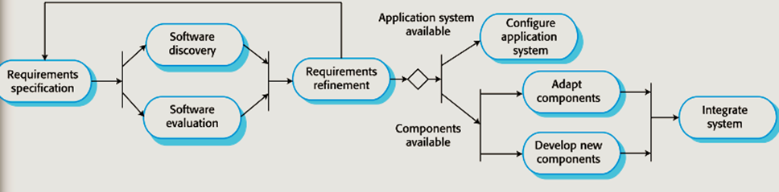

Question 9 (20 mints)

Gantt chart illustrates the project scheduling. Create the Gantt chart from the following project schedule data, comprising 19 tasks having start and end dates showing the duration of the tasks in the number of days, predecessors show the dependencies of the tasks.

1. Create Gantt chart
2. Identify the critical path of the project also.

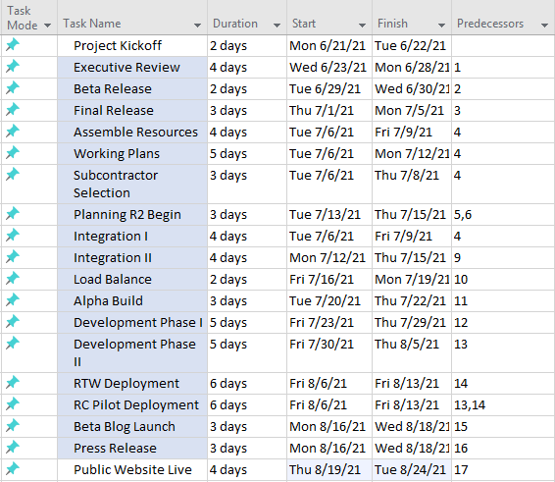

Solution

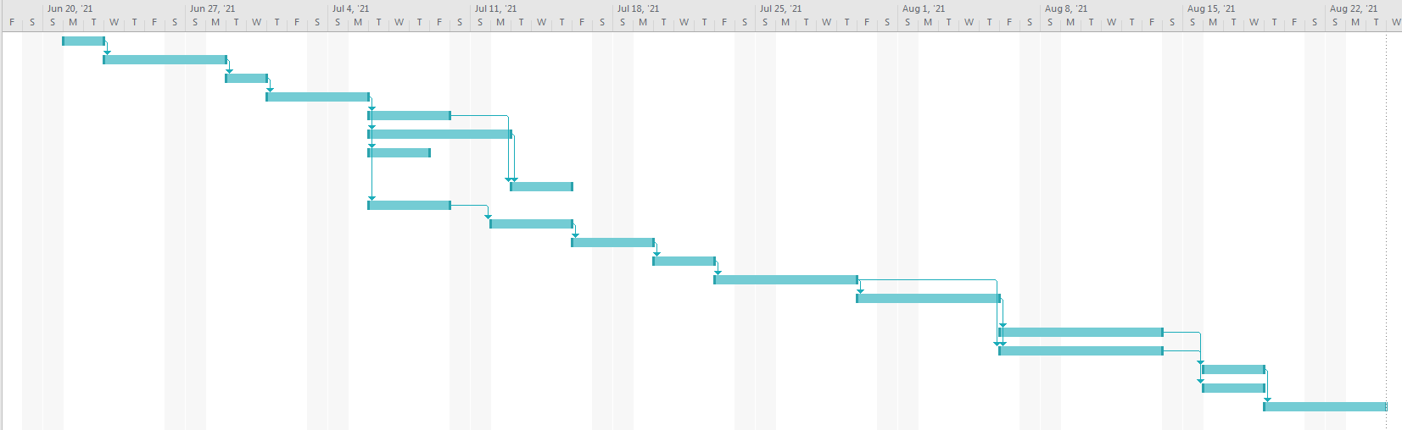

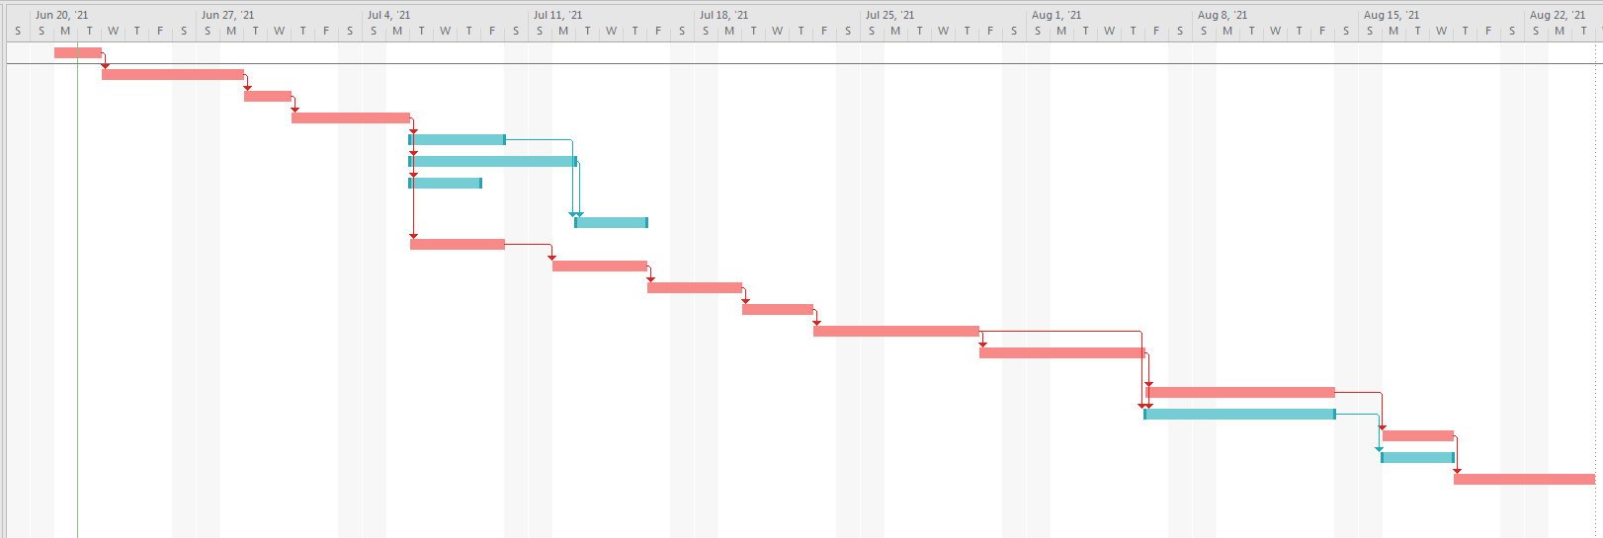

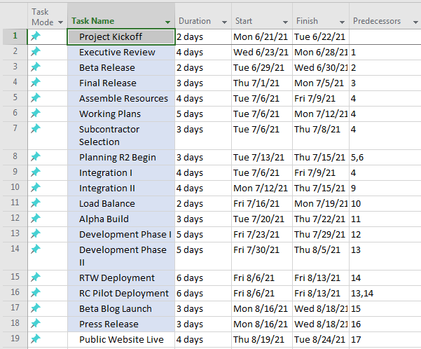

**Critical Tasks: 1,2,3,4,9,10,11, 12, 13, 14, 15, 17, 19**

**Number of days: 2+4+2+3+4+4+2+3+5+5+6+ 3+4= 47 days.**